
BN001/BN012/BN117 Year 2 Project 20xx

Greenhouse Environmental Monitoring and Control

Student Name: _____________________________________________

ID Number: _____________________________________________

Course: _____________________________________________

Due Date: ____________________________________________

Date Submitted: ____________________________________________

The material contained in this project report is the author’s original work, except where work quoted is duly acknowledged in the text. No aspect of this assignment has been previously submitted for assessment in any other unit or course.

Signed: _______________________________ Date: ______/______/______

Table of Contents
List of Figures iii
List of Tables iii
Acronyms iii
Chapter 1 Introduction 1
1.1 Project overview 2
1.2 Project management 2
Chapter 2 Circuit design 3
2.1. How the LCD board works. 3
2.2. How the Sensor and Control board works. 3
Chapter 3 Software Design 6
3.1. Algorithm designs 6
3.2. LCD programming 7
3.3. Display menu using a switch 8
3.4. Temperature measurement and display 8
3.5. Humidity measurement and display 8
3.6. Light level measurement 9
3.7. Fan control 9
Chapter 4 Test Procedure / Results 10
Chapter 5 Process – what I learnt from doing Project. 11
Chapter 6 Safety and Consumer Considerations for the Hardware/Software. 12
Discussion and Conclusion 12
Appendix 14

List of Figures

Figure 1. LCD Display Shield Schematic
Figure 2. Sensor and Control Board Schematic
Figure 3. LCD PCB
Figure 4. Sensor and Control PCB
Figure 5. LCD Algorithm Flowchart
Figure 6. Temperature Algorithm Flowchart

List of Tables

Table 1. Project Timetable
Table 2. Sensor and Control PCB Test
Table 3. Sensor and Control Power Test
Table 4. LCD Test
Table 5. LCD Power Test
Table 6. LCD Functionality Test
Table 7. Sensor and Control PCB Functionality Test

Acronyms

LCD Liquid Crystal Display
ADC Analogue to Digital Converter
PCB Printed Circuit Board
ECAD Electronic Computer Aided Design
GND Ground
PWR Power
IC Integrated Circuit
DC Direct Current
AC Alternating Current
TR1 Transistor 1
LED Light Emitting Diode
LDR Light Dependent Resistor
SW1 Switch 1
R1 Resistor 1
RTH Thermistor
VR1, VR2 Variable Resistor 1 & 2
CON Connector
UV Ultra-Violet
IDE Integrated Development Environment
PPE Personal Protective Equipment

Chapter 1 Introduction

The aim of this second year project is to design and manufacture a set of electronic components as a preface to the world of work awaiting post graduation and/or to be used as an introduction to further project work in subsequent modules in the forthcoming years.

This report presents the development and design process undertaken to produce a functional greenhouse environmental monitoring and control system.

The greenhouse environmental monitoring and control system utilises components such as a programmable Arduino Uno microcontroller interfaced with a liquid crystal display board and a PCB sensor connected to a fan that allows a user to monitor the temperature, humidity and light level within the greenhouse.

The LCD display PCB will act as an Arduino Shield by attaching itself onto the Arduino with connections to the Arduino board ports. The board will be designed in ECAD, as this requires precision alignment, a commercially produced PCB will be provided for actual use in the project.

The Sensor and Control PCB will contain all the control sensors and signal conditioning circuitry. It will interface to the Arduino Shield PCB by a cable.

A description of the environmental monitoring and control system functions and an analysis of its operational efficiency, as well as the design and manufacture of the printed circuit board, will be further discussed throughout this report.

1.1 Project overview
The tasks of this project included the design and development of a functional greenhouse environmental monitoring and control system. This was made up of 4 main areas:
- PCB & LCD designs
- Component assembly
- Wiring Language software development
- Interfacing of Hardware and Software

1.2 Project management
In order to efficiently manage the project, the main tasks mentioned above were divided into sub-sections. This was to enable the procedures and steps required to complete the project, to be broken up into manageable segments and to set the pacing for the projects development over the course of the semester, as can be seen in Table 1.

Project Timetable
Week | Session Objective | Week Beginning | Comments
1 | Overview of Project | 26/01/15 | Start Schematics
2 | Schematic Design | 02/02/15 | Continue Schematics
3 | Design LCD PCB | 09/02/15 | Submit LCD Schematics
4 | Design Sensor Board PCB and Manufacture PCB | 16/02/15 | Submit LCD Artworks and Sensor Board Schematics
5 | Algorithm Design | 23/02/15 | Submit Sensor Board PCB Artworks
6 | Solder LCD Board | 02/03/15 | PCB Manufacture Completion and Submit Algorithms
7 | SMT Humidity PCB Build | 09/03/15 | SMT process cancelled
8 | LCD PCB test and Software Phase 1 | 16/03/15 | Basic LCD PCB Operation
9 | Solder Sensor Control Board and Software Phase 2 | 23/03/15 | LCD Bench Test Assessment
10 | Solder Sensor Control Board and Software Phase 2 | 13/04/15 | Continue Work on Soldering and Software Design
11 | Final Hardware and Software Integration | 20/04/15 | Assessment of all Completed Hardware and Bench Test of Software
12 | Final Report and Hardware Submission | 27/04/15 | Final Submission

Chapter 2 Circuit design

How the LCD board works.

The LCD board used in the project was designed using ECAD design suite software called CadStar. The LCD schematic was initially drawn up using a template that the design was based on. Upon completion of the schematic drawing, the design was then transferred to a PCB artwork for further development. The PCB design entailed the arrangement of components on the board and then connecting the track paths throughout the board while trying to optimize the layout of each components placement. When the PCB’s design is completed, it is then ready to begin the manufacturing process. In this project, the LCD PCB board was pre-manufactured and this step was not applicable.

After testing the PCB for continuity and ensuring the correct placement of parts, the components for the ready-made LCD PCB board were soldered onto the board and a 16x2 character LCD was connected on top of the PCB. The LCD was controlled by attaching an Arduino Uno microcontroller underneath the PCB. The PCB has a variable resistor that is used to either increase or decrease the contrast on the LCD screen.

Once the LCD PCB is setup and everything connected correctly, the board was then programmed by connecting the Arduino to a computer. The Arduino software was used to set up the correct pins and outputs so that the LCD would display text correctly.

How the Sensor and Control board works.

The Sensor and Control board used in the project was also designed using CadStar. The Sensor and Control schematic was drawn up and all components connected accordingly.
During the drawing of the schematic, there was a single resistor, R1, in the fan control section, whose value was left out of the design template. In order to continue further, the resistance of R1 would need to be calculated. To do this, values were obtained from the data sheet. The current for drawn by the fan and by the LED, was used to work out the current drawn on the collector of the transistor, TR1.
Now that the collector current was known, it could be divided by the transistors beta value ( β ) in order to give the base current. Once the base current was known, Ohms Law could be applied to calculate the resistance value. The following information was gathered from the data sheet:

- LED voltage = 5V
- LED voltage drop = 0.7V
- LED resistance = 220Ω

Ohms law ( I = V / R);
(5V – 0.7V) / 220Ω = 0.01954 A

The current of the fan = 0.245 A

Therefore;
0.254 + 0.01954 = 0.26454 A

The beta value ( β ) of the transistor = 100 – 630
The lower value was chosen as a precautionary measure, so beta ( β ) = 100.

The current of the fan could be divided by the beta value now.
0.26454 / 100 = 0.0026454 A

Ohms law (R = V / I);
(5V – 0.7V) / 0.0026454 A = 1625.46Ω

R1 = 1625.46Ω

As there are no resistors available in the calculated size, a resistor of its nearest value was selected from a resistor pack. The nearest values available were 1kΩ, 1.2kΩ or 2.2kΩ. Taking the smaller value as a safety measure, the value of 1.2kΩ was selected.

Once the schematic drawing was complete, the design was then transferred to the PCB design process for further development of the artwork. The PCB design required the board to be one sided and thus required more work than the previous LCD PCB design. It was necessary to try and optimize the layout of the PCB design to try and reduce the number of via’s on the board. Once the PCB’s layout was finalized, the manufacturing process could begin.

Once prepared for manufacture, the artwork was then printed out on special tracing paper. A blank PCB copper sheet was provided and after removing its protective plastic layer, the artwork was placed face down onto the PCB and vacuum-sealed in a UV scanner, which used UV rays to imprint the design onto the PCB copper sheet. While taking care not to touch the photosensitive side of the board after it was scanned, it was transferred to the etching tanks for a 4 stage chemical process. The board would require rinsing in between each of the 4 stages.

- Stage 1 – The Developing Tank.

The PCB in inserted into the developing tank for approximately 10 to 20 seconds, until the traces become clear and the exposed photosensitive layer is dissolved from the board.

- Stage 2 – The Etching Tank.

The PCB in inserted into the etching tank for approximately 10 to 15 minutes, etching tank chemically removes the copper from all areas not covered with the imprinted photoresist.

- Stage 3 – The Photoresist Stripping Tank.

Before this step, the board is scrubbed using a grey scrub pad. The PCB in inserted into the photoresist-stripping tank for approximately 1 minute. The remaining photoresist is chemically removed or stripped away, leaving only copper on the panel. The copper tracks and ground plane of the boards are now exposed.
- Stage 4 – The Tinning Tank.

The PCB in inserted into the tinning tank for approximately 10 to 12 minutes. As the copper tracks are now visible and exposed to the elements, a protective layer has to be put on the copper tracks otherwise they would oxidize, making them unusable.

After the 4 stage chemical process was complete, the next step was to drill out the component holes. After the holes were drilled, a guillotine was used to remove the excess PCB from the board and then the PCB was double checked to see if any holes had been missed. The components were then added to the board, soldered and checked for continuity. The components attached included a thermistor, used for calculating the temperature, an LDR to measure the light levels, a humidity sensor, as well as diodes, 4 resistors, 2 variable resistors, a transistor, an LED and 2 integrated circuit chips.

Once the Sensor and Control PCB was designed and manufactured, it was then connected to the LCD PCB through the D type 15 pin cable ports and powered by connecting to 5V and ground. The sensor and control board was now complete and ready to being testing.

Chapter 3 Software Design

Algorithm designs

An algorithm is an effective step-by-step set of instructions, used to find the optimal path through a problem, in order to complete the task.

The first algorithm for this project was the LCD mode switch algorithm. It must enable the user to be able to push a button and switch through the LCD display menu. The LCD display menu must then toggle through each mode until it returns its point of origin. A flowchart was used to visualize the algorithm and can be seen in Figure 5.

The second algorithm for this project was the Temperature Reading algorithm. This algorithm must enable the user to view the correct temperature on the LCD while in temperature mode. To do this, the algorithm would incorporate a simplified Steinhart-Hart equation, then convert the temperature from Kelvin to Celsius and print the new temperature onto the LCD screen. A flowchart was used to visualize the algorithm and can be seen in Figure 6.

LCD programming

The greenhouse environmental monitoring and control system requires some computer programming to enable all the components to properly interface with one another. This was done using the wiring language and complied in the Arduino IDE software program.

The programs all consist of three main parts, structure, values and functions.

Structures include commands like setup() and loop() as well as controllers such as if statements, while loops, for loops, switch cases and break statements.

Values are constants, for example; HIGH and LOW, INPUT and OUTPUT. Values can also be variables and data types such as void, int, float and doubles.

Functions include commands such as pinMode() and digitalRead and digitalWrite and delay().

To program the LCD, the <LiquidCrystal.h> header file must be included at the start of the program. Variables must be declared and pins initialized. The LCD uses pins (12, 11, 5, 4, 3, 2) and the command to set up the pins is: LiquidCrystal lcd(12, 11, 5, 4, 3, 2);

The full code can be found in the appendices.

Display menu using a switch

To program the LCD display menu switch sequence, multiple switch-case and break statements were used. Once the mode select button is triggered, the switch-case is incremented, breaks out of the current case and switches to the next case in the sequence.

A small delay was used as a method of debouncing the button presses.
The code used to do this is: val = digitalRead(switchPin);

Temperature measurement and display

To enable the temperature to take accurate measurements and display them on the LCD screen, a series of actions need to be performed in the code. First, to measure the temperature, the ADC value must be read and then its value is multiplied by the thermistor value and then divided by 1023 minus the ADC value. The value of 1023 is the ADC value for the full 5 volt reference voltage. Then the Steinhart equation can calculate the temperature in Kelvin. It is then converted from Kelvin to Celsius by subtracting 273.15 and displayed on the LCD screen when the temperature mode is selected on the LCD.

Humidity measurement and display

Unfortunately, due to issues with the SMT lab not going ahead, the SMT process was unable to be completed and the Humidity reading could not be implemented into the project in time.

Light level measurement

The light level measurement was calculated using a photodiode that increases and decreases its resistance values, based on how much light is shining on it. The level of light is measured in lux. This works by reading the ADC value and multiplying it by the input voltage of 5 volts and dividing by the reference voltage of 1023, to calculate the voltage. The lux value is then figured out by multiplying the calculated voltage by a constant value of 1333.

Fan control

The fan is controlled in two different ways in the project, the primary method requires the fan to automatically switch on when a preset temperature value has been reached and to stay on until it drops below the target temperature. The second method is for the fan to be manually switched on when the LCD menu mode select for the fan on command is enable, the next menu mode select option is to disable the fan upon switching to fan off mode. This is done using the digitalWrite(fan, HIGH) and digitalWrite(fan, LOW) commands.

Chapter 4 Test Procedure / Results

The testing procedure for this project included carrying out continuity tests on all the components on both the LCD PCB and on the Sensor and Control board PCB. An excel spreadsheet was used to list all the different parts and components and each item was then checked and verified throughout the test procedure to ensure no components were missed or left out. The testing checklist can be seen in Tables 2 - 7.

A digital multi-meter was used to check the continuity in each circuit. The diodes, resistors, variable resistors, transistor and LED’s were checked first. Initially they were checked for correct placement and then tested for continuity. The connectors were checked next and their pins were all tested to ensure proper connection to their corresponding tracks.

Once all the components and connectors were correctly verified, the power and ground tracks were then tested. After testing was complete, the excel spreadsheet was double checked to confirm that all the results of the test had been added to it.

Chapter 5 Process – what I learnt from doing Project.

At the very start of the semester, the skills I had previously acquired enabled me to have a strong starting point for beginning this project. The ECAD module in the previous semester left me with the knowledge I needed to draw the schematics and there was adequate time to spend designing the PCB’s, as well as learning from any mistakes that were inevitably made during the process. One of the biggest learning curves that I encountered throughout the project was while trying to optimize the layout of the sensor and control board PCB artwork while trying to reduce the overall board size. I found this to be very frustrating but rewarding in the end as I was very happy with my final board size and its layout.
Although there were a few areas that I felt I was weak in initially, such as writing code in the wiring language and using the Arduino IDE, the pacing throughout the project ensured that there was enough time to learn and experiment with the code. The result was a much stronger familiarity and knowledge in both.

Good time management was very important to make sure that all the deadlines were met on time and having an idea of what needs to be achieved prior to each labs commencement, helped a good deal to meeting the targets.

Soldering and drilling skills were further increased throughout the project and new skills were acquired, such as learning how to manufacture the PCB’s and an understanding of how each stage of the process works.

Chapter 6 Safety and Consumer Considerations for the Hardware/Software.

All health and safety procedures must be adhered to while working in the lab environment to ensure the safety of both the individual and the group as a whole.
The rules and regulations of the lab environment require students to wear proper PPE when operating any machinery and to conduct themselves in a disciplined manner, this includes:
- Wearing protective goggles when soldering and drilling.
- Proper ventilation or a vacuum pipe when soldering.
- The safety guard should be used when operating the drill.
- Care must be taken when using any cutting tools to cut wires etc.
- No distractions to anyone operating the drill.
- Gloves and lab coat must be worn when in the PCB manufacturing room
- Lab access must be supervised at all times.

Other considerations must be taken into account when using any hardware. The components and boards must be checked prior to applying a power source to ensure nothing will create a short circuit and to reduce any potential damage to the components and boards.

With regards to the safety considerations of software, care must be taken not to disconnect the cables when uploading software from the computer to the Arduino and all work must be regularly saved or backed up to stop the potential loss of work should there be any issues with the computer crashing or power loss etc.

Due to increasing greenhouse gas emissions from human activities, the greenhouse effect has been significantly increased, causing the earth’s surface temperature to rise. The temperature rise had led to climate change. If this project was to be mass produced, there are a few ethical issues that would need to be considered.

The process of manufacturing the greenhouse environmental monitoring and control systems would need to be done on an industrial scale, as the workload would be too much for an individual to produce alone as well as being an inefficient process. This would result in the greater consumption of plastics and metals needed for the production of its PCB’s and the volume of solder required for the electronic components would all have an impact on the environment.

Discussion and Conclusion
In this second year project, the aim was to design and implement a working and user-friendly greenhouse environmental monitoring and control system. The users of the system should be able to easily monitor and adjust the temperature inside the greenhouse.

The issue of climate change is one that is showing no signs of going away any time soon and the development of skills and knowledge in this field are certainly useful. There is still a lot of room for future development of this project, which would potentially enhance the system and increase its value. Current technology allows for even greater depth of technicality and application of features such as remote monitoring and control as well as the relationship to the Internet of Things, which would allow for increased access and expansion of the project.

The pacing of the project meant that the need to learn different concepts and techniques was very manageable and relevant to the project, resulting in quick application to the monitoring and control system. The project also provided a chance for us to further accumulate experience in the development and application of software writing and using the Arduino IDE.

Many new skills have been learned through the project and the challenge presented by the complexity of the technologies needed to build the system resulted in an improvement in both old and new abilities. The experience of completing a project like this, from beginning to end, results in a solid foundation of knowledge, which is advantageous for any future projects.

This project experience has greatly enriched my knowledge and sharpened my technical skills.

Appendix

Figure 1. LCD Display Shield Schematic

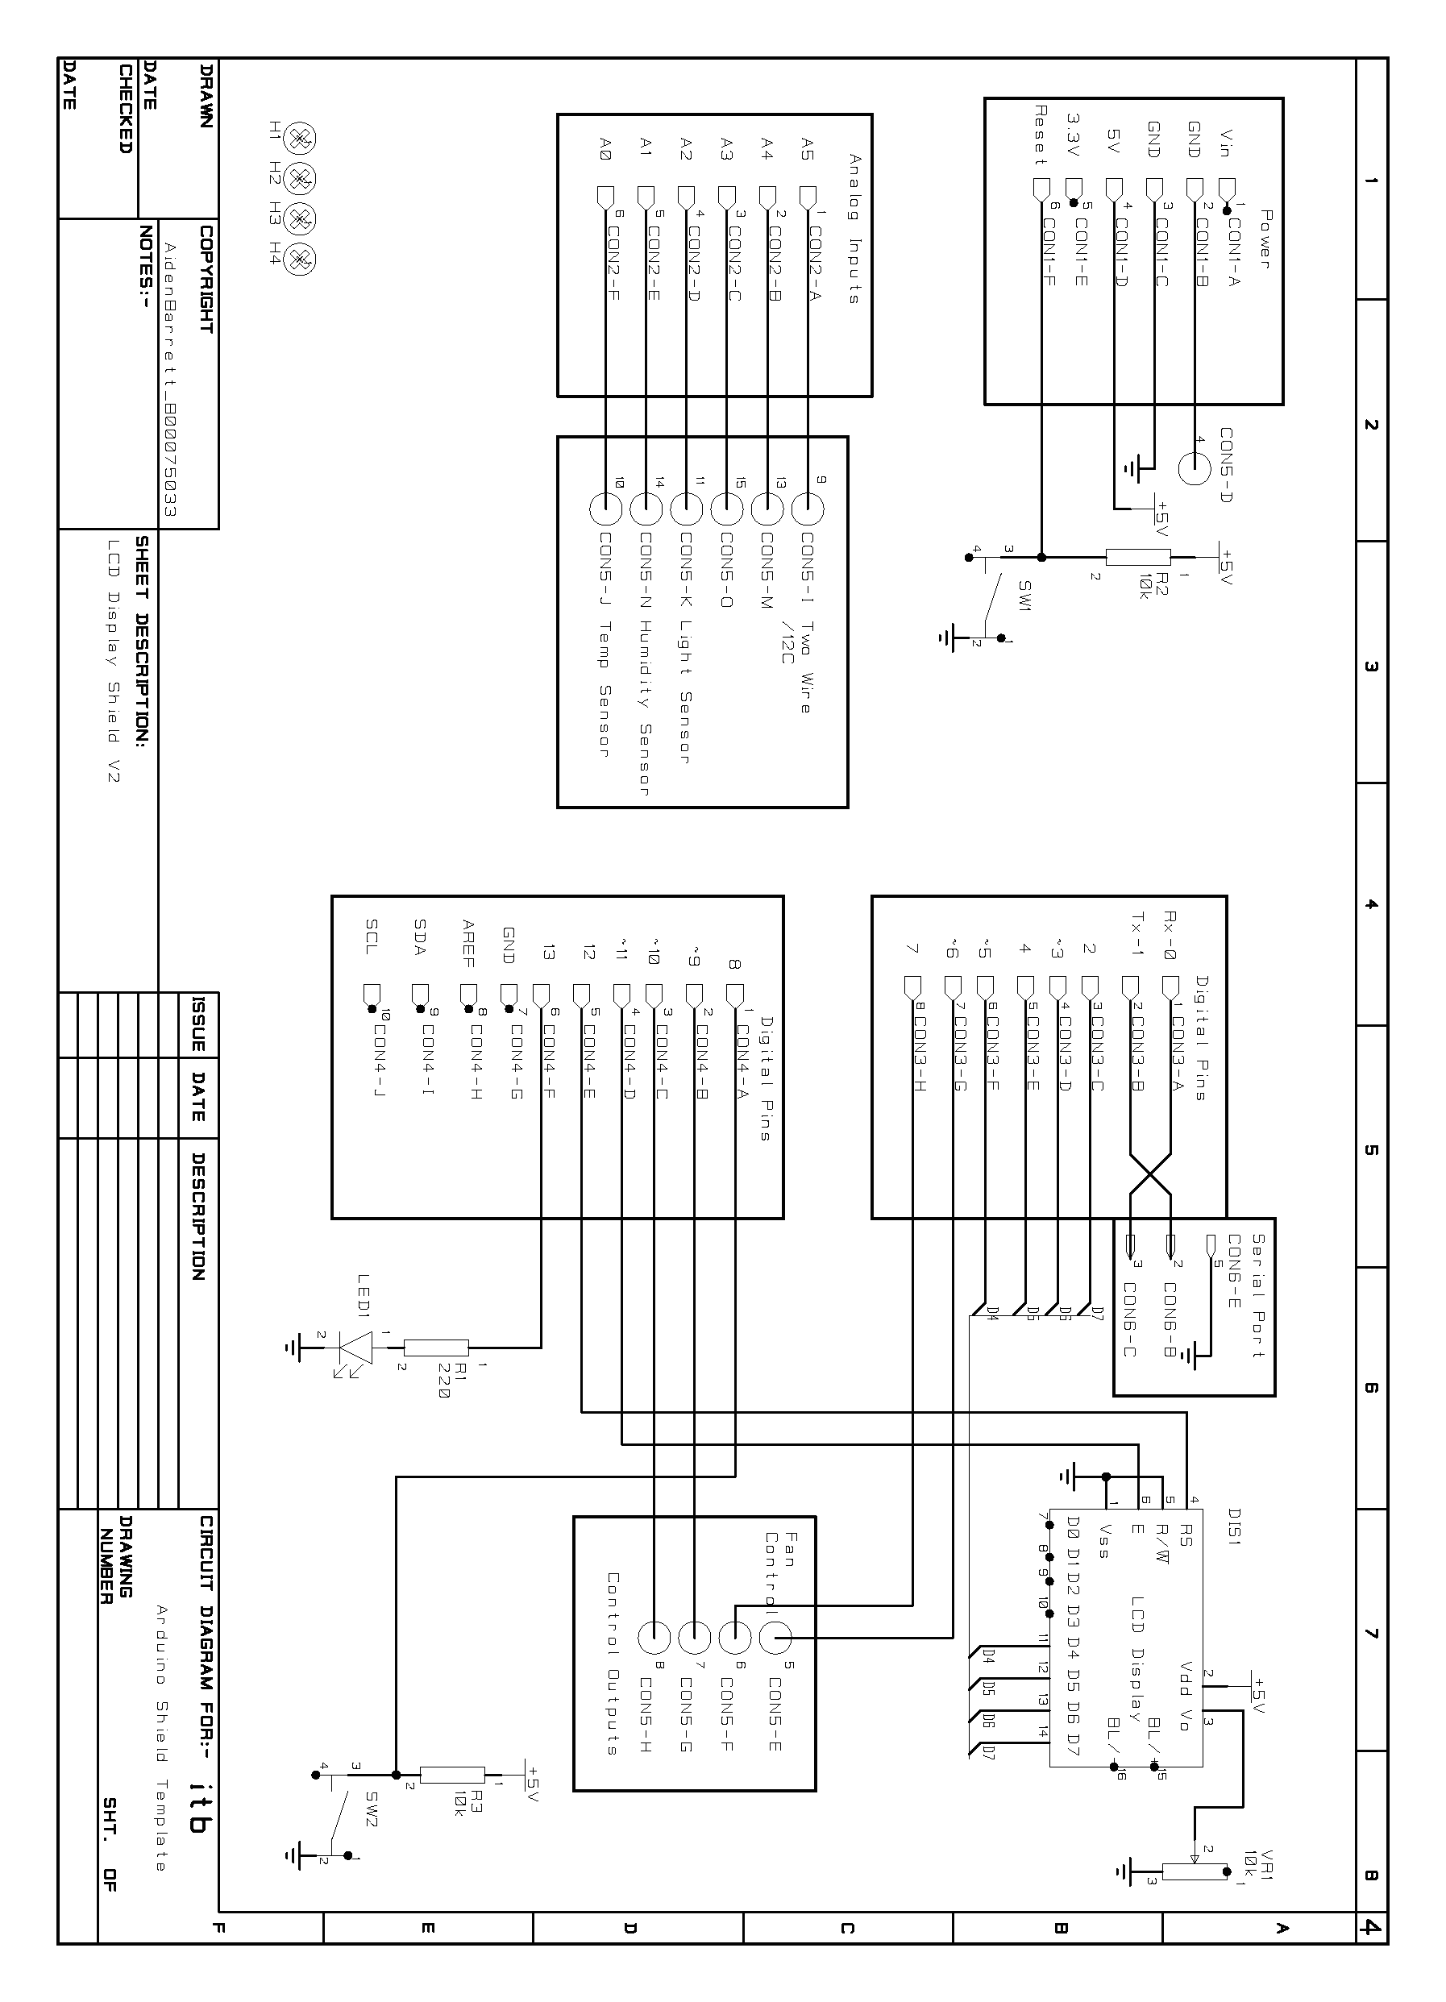
Figure 2. Sensor and Control Board Schematic

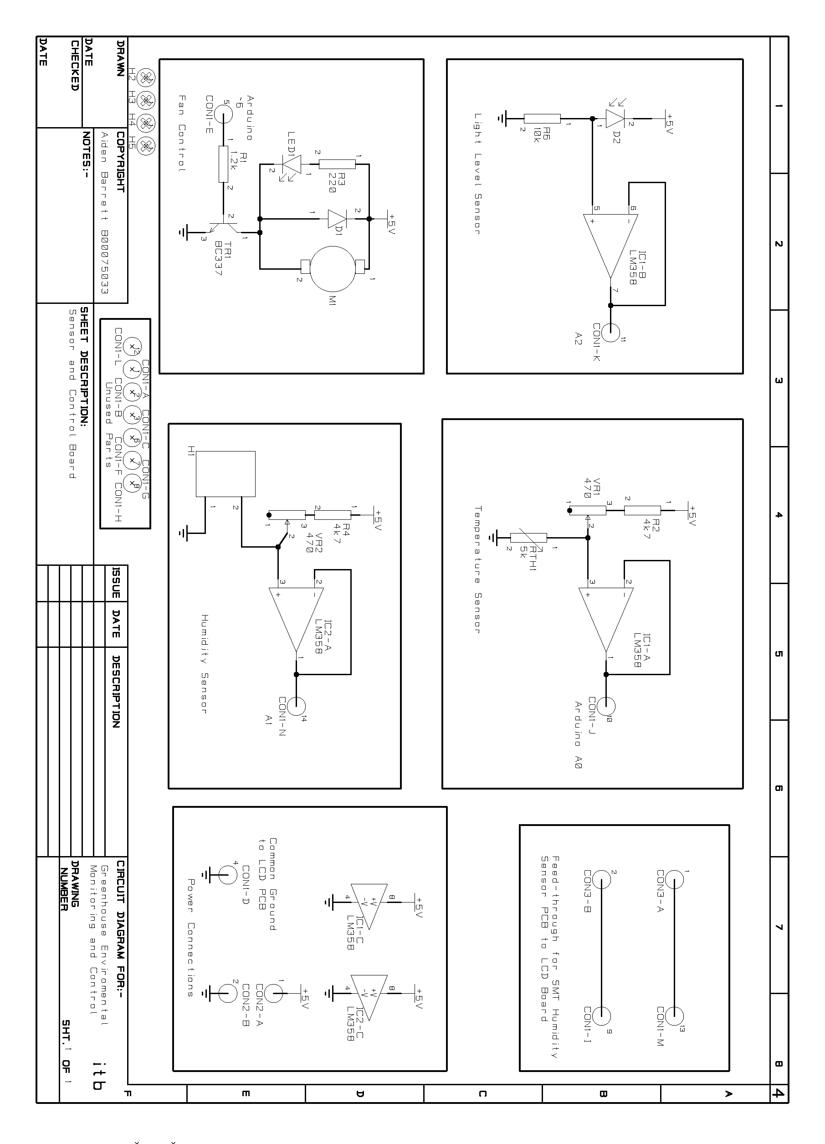
Figure 3. LCD PCB

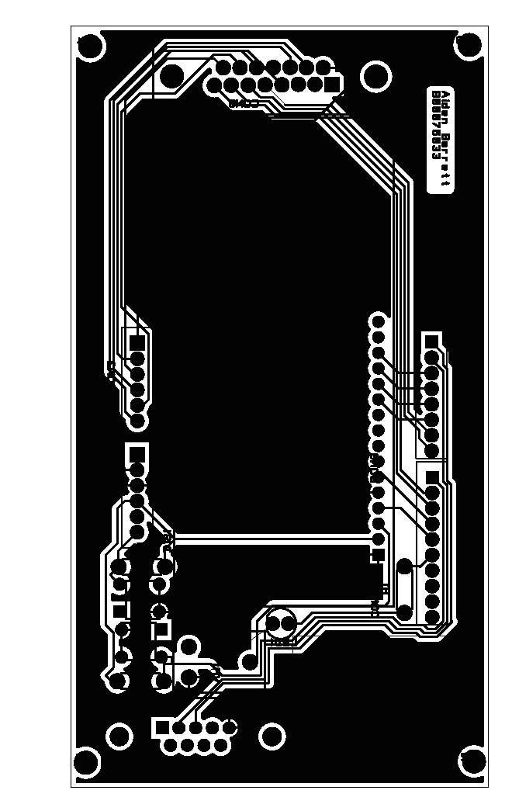

Figure 4. Sensor and Control PCB

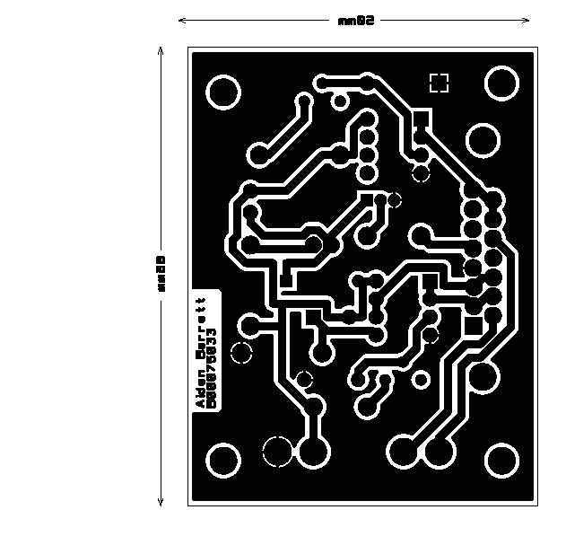

Figure 5. LCD Algorithm Flowchart
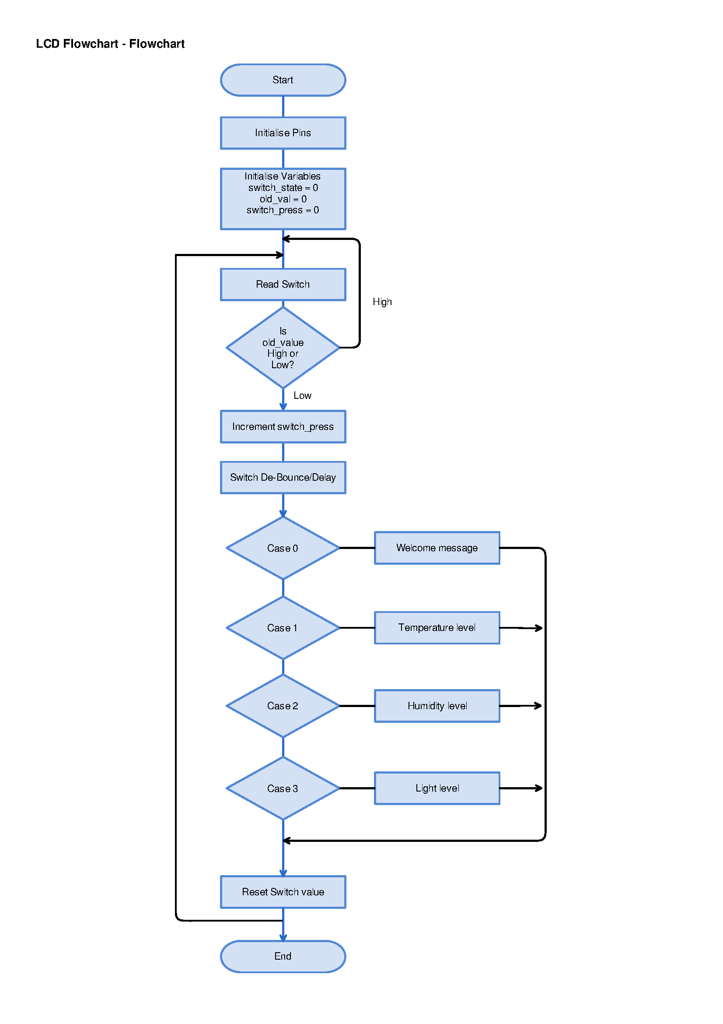

Figure 6. Temperature Algorithm Flowchart

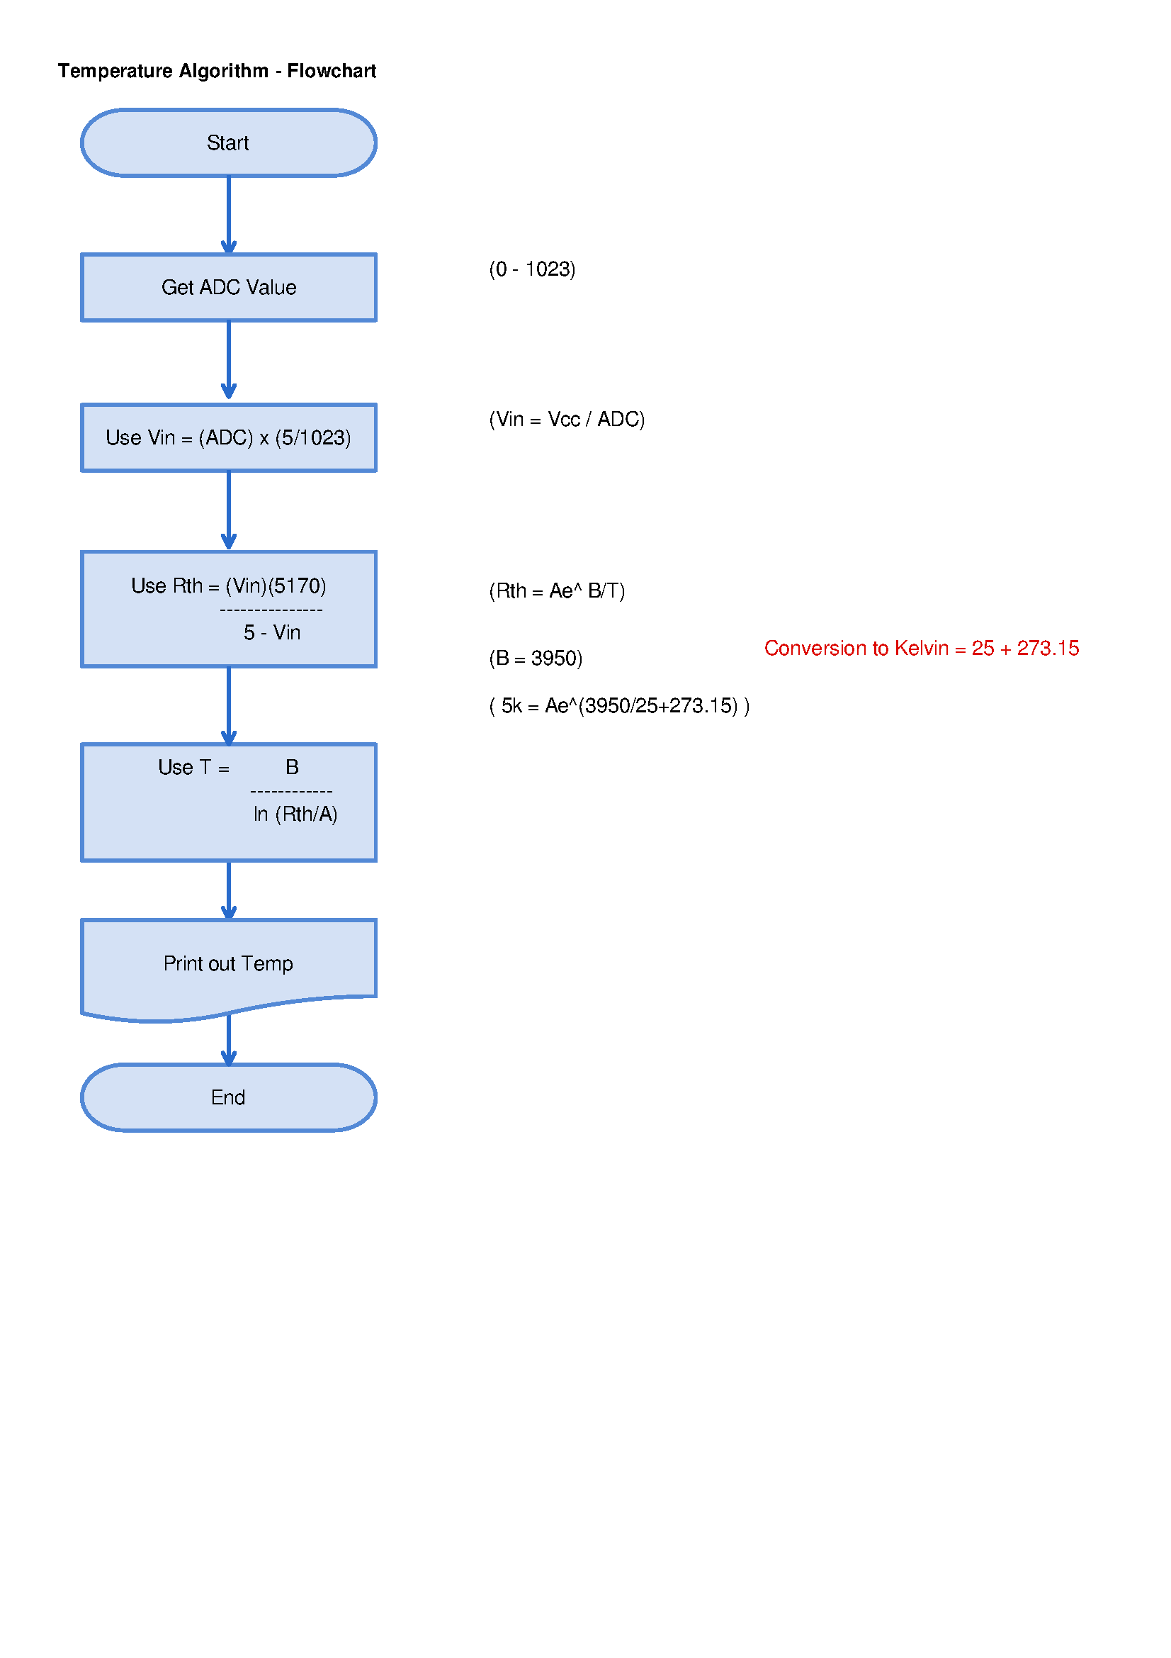
Table 1. Project Timetable

Table 1 - Project Timetable
Week | Session Objective | Week Beginning | Comments
1 | Overview of Project | 26/01/15 | Start Schematics
2 | Schematic Design | 02/02/15 | Continue Schematics
3 | Design LCD PCB | 09/02/15 | Submit LCD Schematics
4 | Design Sensor Board PCB and Manufacture PCB | 16/02/15 | Submit LCD Artworks and Sensor Board Schematics
5 | Algorithm Design | 23/02/15 | Submit Sensor Board PCB Artworks
6 | Solder LCD Board | 02/03/15 | PCB Manufacture Completion and Submit Algorithms
7 | SMT Humidity PCB Build | 09/03/15 | SMT process cancelled
8 | LCD PCB test and Software Phase 1 | 16/03/15 | Basic LCD PCB Operation
9 | Solder Sensor Control Board and Software Phase 2 | 23/03/15 | LCD Bench Test Assessment
10 | Solder Sensor Control Board and Software Phase 2 | 13/04/15 | Continue Work on Soldering and Software Design
11 | Final Hardware and Software Integration | 20/04/15 | Assessment of all Completed Hardware and Bench Test of Software
12 | Final Report and Hardware Submission | 27/04/15 | Final Submission

Table 2. Sensor and Control PCB Test

Test Description: |  | Continuity Test
Notes: | No Ic's in Sockets
 | No Power connected
Instructions: | Check for continuity using Multimeter
 | From |  | To | Check
Label | Pin | Label | Pin No
CON 1 | PIN 2 | IC1 | PIN 2 | YES
CON 1 | PIN 10 | CON 1 | PIN 2 | YES
CON 1 | PIN 3 | IC 2 | PIN 7 | YES
CON 1 | PIN 5 | R1 | PIN 1 | YES
CON 1 | PIN 8 | IC 2 | PIN 2 | YES
CON 1 | PIN 9 | CON 3 | PIN 2 | YES
CON 1 | PIN 11 | CON 1 | PIN 3 | YES
CON 1 | PIN 13 | CON 3 | PIN 1 | YES
CON 1 | PIN 14 | CON 1 | PIN 15 | YES
CON 1 | PIN 15 | CON 1 | PIN 8 | YES
VR2 | PIN 3 | R4 | PIN 2 | YES
VR2 | PIN 2 | H1 | PIN 2 | YES
IC2 | PIN 1 | IC2 | PIN 2 | YES
IC2 | PIN 2 | CON 1 | PIN 14 | YES
IC2 | PIN 3 | H1 | PIN 2 | YES
R1 | PIN 2 | TR1 | PIN 2 | YES
TR1 | PIN 1 | LED | PIN 2 | YES
LED | PIN1 | R3 | PIN 2 | YES
LED | PIN 2 | M1 | PIN 2 | YES
LED | PIN 2 | D1 | PIN 1 | YES
IC1 | PIN 1 | IC1 | PIN 2 | YES
IC1 | PIN 3 | VR1 | PIN 2 | YES
IC1 | PIN 5 | D2 | PIN 1 | YES
IC1 | PIN 6 | IC1 | PIN 7 | YES
VR1 | PIN 2 | RTH1 | PIN 1 | YES
VR1 | PIN 3 | R2 | PIN 2 | YES

Table 3. Sensor and Control Power Test

Test Description: |  | Power Pin Check
Notes: | No Display
 | Power Connected
Instructions: | Check for 5v and 0V using Multimeter
From | Pin No | To | Pin No | Check
Vcc
IC2 | PIN 8 | R4 | PIN 1 | YES
R4 | PIN 1 | M1 | PIN 1 | YES
M1 | PIN 1 | D2 | PIN 2 | YES
D2 | PIN 2 | D1 | PIN 2 | YES
D1 | PIN 2 | IC1 | PIN 8 | YES
M1 | PIN 1 | R3 | PIN 1 | YES
R3 | PIN 1 | R2 | PIN 1 | YES
R2 | PIN 1 | CON 2 | PIN 1 | YES
GND
CON 1 | PIN 4 |  |  | YES
IC2 | PIN 4 |  |  | YES
TR1 | PIN 3 |  |  | YES
IC1 | PIN 4 |  |  | YES
H1 | PIN 1 |  |  | YES
R6 | PIN 2 |  |  | YES
CON 2 | PIN 2 |  |  | YES
RTH | PIN 2 |  |  | YES

Table 4. LCD Test

Test Description: |  | Continuity Test
Notes: | No Power connected
Instructions: | Check for continuity using Multimeter
From | Pin | To | Pin No | Check
R4 | Pin 1 | +5V | CON4 PIN2 | Yes
R4 | Pin 2 | SW1 | Pin 3 | Yes
Con 1 | Pin 2 | GND | CON5 PIN4 | Yes
Con 1 | Pin 3 | GND | VR1 | Yes
Con 1 | Pin 3 | GND | SW2 | Yes
Con 1 | Pin 3 | GND | CON4 PIN5 | Yes
Con 1 | Pin 3 | GND | SW1 | Yes
Con 1 | Pin 4 | +5V | CON4 PIN2 | Yes
Con 1 | Pin 4 | +5V | R2 | Yes
Con 2 | Pin 1 | A5 | CON5 PIN9 | Yes
Con 2 | Pin 2 | A4 | CON5 PIN13 | Yes
Con 2 | Pin 3 | A3 | CON5 PIN15 | Yes
Con 2 | Pin 4 | A2 | CON5 PIN14 | Yes
Con 2 | Pin 5 | A1 | CON5 PIN12 | Yes
Con 2 | Pin 6 | A0 | CON5 PIN8 | Yes
Con 3 | Pin 3 | D2 | CON4 PIN14 | Yes
Con 3 | Pin 4 | D3 | CON4 PIN13 | Yes
Con 3 | Pin 5 | D4 | CON4 PIN12 | Yes
Con 3 | Pin 6 | D5 | CON4 PIN11 | Yes
Con 3 | Pin 7 | D6 | CON5 PIN4 | Yes
Con 3 | Pin 8 | D7 | CON5 PIN3 | Yes
Con 4 | Pin 9 | D8 | R2 & SW2 | Yes
Con 4 | Pin 10 | D9 | CON5 PIN2 | Yes
Con 4 | Pin 11 | D10 | CON5 PIN1 | Yes
Con 4 | Pin 12 | D11 | CON4 PIN6 | Yes
Con 4 | Pin 13 | D12 | CON4 PIN4 | Yes
Con 4 | Pin 14 | D13 | R1 | Yes

Table 5. LCD Power Test

Test Description: |  | Power Pin Check
Notes: | No Display
 | Power Connected
Instructions: | Check for +5V and 0V using Multimeter
 | Label | Pin No | Check
Vcc | DIS1 | Pin 2 | Yes
 | R4 | Pin 1 | Yes
 | R3 | Pin 1 | Yes
GND | DIS1 | Pin 1 | Yes
 | DIS1 | Pin 5 | Yes
 | SW1 | Pin 1 | Yes
 | SW2 | Pin 2 | Yes
 | LED1 | Pin 2 | Yes
 | VR1 | Pin 3 | Yes

Table 6. LCD Functionality Test

Test Description: |  | Functional test
Notes: | Insert Display after checking all other functionality
 | Power Connected
 | Use Multimeter
Label | Description | Check for | Pin No | Check
SW1 | Mode Switch | low/high | Pin 3 | Yes
SW2 | Reset Switch | low/high | Pin 4 | Yes
VR1 | Contrast Control | Varying Voltage | Pin 2 | Yes

Table 7. Sensor and Control PCB Functionality Test

Test Description: |  | Functional test
Notes: | All components in place
 | Power Connected
 | Use DMM
Label | Description | Check for | Pin No | Check
Con 1 | Thermistor input(A0) | varying voltage | Pin 10 | Yes
Con 1 | Humidity input(A1) | varying voltage | Pin 14 | Yes
Con 1 | Light input(A2) | varying voltage | Pin 11 | Yes

Software Code
/*
Greenhouse Environmental Monitoring and Control BN0012 Year 2 Project 2015
by B00075033 https://aidenbarrett.wordpress.com/

*/

// include the library code:
#include <LiquidCrystal.h>

// *** Variable decalarations ***

const int switchPin = 8; // Mode select switch input pin
int sw_state = 0; // New value of the mode switch
int switch_presses = 0; // Number of presses of the mode switch
int val; // Stores val of mode switch
int oldval = 0; //Stores the previous value of the mode switch

LiquidCrystal lcd(12, 11, 5, 4, 3, 2); // The interface pin numbers

int led = 13; // sets up LED pin
int fan = 6; // sets up fan pin.
float temperature;
float lux_value;

void setup() {

lcd.begin(8, 2);
pinMode(switchPin,INPUT); // Set as input for the mode switch
pinMode(led,OUTPUT); // Set as output for LED
pinMode(fan,OUTPUT); // Set as output for fan
pinMode(A0, INPUT); // Sets A0 as temperature input pin
pinMode(A2, INPUT); // Sets A2 as light sensor input pin

}

void loop() {

// **** Mode Select ****

val = digitalRead(switchPin); // Read the mode switch

//Update the number of switch presses and inplement soft switch debounce
if ((val == LOW) && (oldval == HIGH)){
switch_presses = switch_presses +1;

delay(50); // 50ms debounce delay
}

oldval = val; //val is now old so store it

digitalWrite(led,HIGH);

// Display whichever dipslay mode has been selected
switch(switch_presses){

case 0:

// *** Welcome Message ***
lcd.setCursor(0,0); // Greeting message
lcd.print("Aidens P");

lcd.setCursor(0,1);
lcd.print("roject ");

break;

case 1:

// ** TEMPERATURE MODE **

TEMP();

lcd.setCursor(0,0);
lcd.print("Temp: ");
//delay(200);
lcd.setCursor(0,1);
lcd.print(temperature);
lcd.setCursor(5,1);
lcd.print("oC ");

break;

case 2:

// ** HUMIDITY MODE **
lcd.setCursor(0,0);
lcd.print("Humidity");

lcd.setCursor(0,1);
lcd.print(" Mode ");

break;

case 3:

// ** Light Level MODE **
LIGHT();

lcd.setCursor(0,0);
lcd.print("Light: ");

lcd.setCursor(0,1);
lcd.print(lux_value);
//delay(700);
lcd.setCursor(5,1);
lcd.print("lx"); // lx, measure of one lumen per square metre.

break;

case 4:

// *** Fan ON Mode ***
lcd.setCursor(0,0);
lcd.print("Fan Mode");

lcd.setCursor(0,1);
lcd.print(": On ");
digitalWrite(fan,HIGH);

break;

case 5:

// *** Fan OFF Mode ***
lcd.setCursor(0,0);
lcd.print("Fan Mode");

lcd.setCursor(0,1);
lcd.print(": Off ");
digitalWrite(fan,LOW);

break;

default:

// ** Last Mode so setup to Start Selection Again **
switch_presses = 0;

} // end of switch cases

delay(300); // more managable delay, reduce polling delay between presses.
lcd.clear(); // clear screen

} // end void loop

void TEMP(void)
{

float Rt = 4700;
float ADC;
float init_kelvin = 298.15; // 25 degrees celcius in kelvin
float BETA = 3950; // Beta constant
float Rth = 5000; // Resistance of thermistor at 25 degrees celcius

ADC = analogRead (A0); // reads analog pin A0

float temp, rtemp;
float a;
float b;

// thermister multiplied by ADC value, divided by, the ADC value minus 1023.
a = (Rth * ADC);
b = (1023 - ADC);
Rt = a / b;

temp = 1 / ( (1/init_kelvin) + (1/BETA) * log (Rt/Rth) ); // steinhart equation
temperature = temp - 273.15; // temperature converted to celcius;

if (temperature >= 28)
{
digitalWrite(fan,HIGH); //fan on
}

else
{
digitalWrite(fan,LOW); //fan on
}

}

void LIGHT (void)
{

float voltage;
float ADC2;

ADC2 = analogRead(A2); //analog read from pin A2

voltage = ADC2 * 5.0 / 1023.0;
lux_value = voltage * 1333.0;

}

